**Performance Evaluation of the Artificial Neural Network Based on the Classification of Parkinson's Disease**

, Sakthivadivel M2, Parimala Devi M3

1Department of ECE, CMR Institute of Technology, Bangalore, India

2Department of AI &DS, Karpagam College of Engineering, Coimbatore, India

3Department of ECE, Veil.com, parimaladevi.vlsi@gmail.com

**Parkinson's disease is a type of disease caused by the loss of dopamine-producing cells in the brain. As the amount of dopamine decreases, the symptoms of Parkinson's disease emerge. Parkinson's disease is a slow-developing disease, and symptoms such as hands, arms, legs, chin and face tremors are increasing over time. As the disease progresses, people may have difficulty in walking and speaking. There is no definitive treatment for Parkinson's disease; however, with the help of some drugs, the symptoms of the disease can be reduced. Although there is no definitive treatment for Parkinson's disease, the patient can continue his normal life by controlling the problems caused by the disease. At this point, it is important to prevent early detection and progression of the disease. In this study, the classification methods such as Support Vector Machine, and K –nearest neighbor are compared in order to predict Parkinson's disease. The device’s performance is assessed in terms of accuracy, sensitivity, specificity, precision, and f-measure. Results show that among the classifiers, KNN has the highest accuracy, at 93.84%.**

**Keywords—*Parkinson’s Disease (PD), supervised learning algorithms.***

# INTRODUCTION

Parkinson’s disease is a brain disorder that causes

unintended or uncontrollable movements, such as shaking, stiffness, and difficulty with balance and coordination.

Symptoms usually begin gradually and worsen over time. As the disease progresses, people may have difficulty walking and talking. They may also have mental and behavioral changes, sleep problems, depression, memory difficulties, and fatigue.

Tremor, discomfort, bradykinesia, and postural instability are the four primary signs and symptoms of Parkinson's disease. A tremor is an uncontrollable shaking of the hands, arms, legs, or jaws. While bradykinesia is defined as sluggish movement, rigidity is the lack of flexibility in the limbs and trunk. Other signs and symptoms may include anxiety, stress, and other emotional changes; difficulties eating, speaking, or swallowing; constipation or urinary issues; skin issues; and disturbed sleep virtually anyone could be at risk for developing Parkinson’s, some research

studies suggest this disease affects more men than women. It’s unclear why, but studies are underway to understand factors that may increase a person’s risk. One clear risk is age: Although most people with Parkinson’s first develop the disease after age 60, about 5% to 10% experience onset before the age of 50. Early-onset forms of Parkinson’s are often, but not always, inherited, and some forms have been linked to specific alterations in genes.

There are six straightforward steps that need to be taken in order to use the machine learning model:

1. Assembling and Analyzing data
2. Selecting the algorithm
3. Creating the model object
4. Training dataset should be used to train the model.
5. Data validation or covert data forecasting

6. Examine the model.

# RELATED WORKS

Disease prediction is an important step in early disease diagnosis in the current, overpopulated world. The creation of several machine learning algorithms has made the prediction simpler. The accuracy of the model is, however, significantly impacted by the complexity and choice of the best machine learning technique for the supplied dataset. There are many datasets available globally, but their unstructured nature prevents them from being used effectively. As a result, one of the key metrics for assessing the model is accuracy.

[Ishu Gupta and *et.al*. (](https://arxiv.org/search/cs?searchtype=author&query=Gupta%2C%2BI)2022) proposed a Parkinson's disease-specific random forest classifier technique for illness prediction.

[Asmae Ouhmida and *et.al*. (2022),](https://ieeexplore.ieee.org/author/37088919732) concentrates on assessing and evaluating the ML techniques, which are Support Vector Machine (SVM), K-Nearest Neighbours (KNN), Logistic Regression (LR), Decision tree (DT),

Discriminant Analysis (DA), Bagging tree (BT), Random Forest (RF), AdaBoost, and Naive Bayes (NB) Classification methods used to categorize 240 speech measurements from a Parkinson's dataset with 44 features, and the performance of each classifier was assessed using a range of evaluation criteria.

[Ghayth AlMahadin and *et.al*. (2021),](https://link.springer.com/article/10.1007/s42979-021-00953-6#auth-Ghayth-AlMahadin) suggested to combine the signal processing with over-sampling, under- sampling and combinations of the sampling techniques. The classifiers like the multi-layer perceptron-based artificial neural network and random forest are integrated with resampling techniques. Complex metrics including the geometric mean, area under the curve, and balanced accuracy index are used to assess these procedures. The findings indicate that hybrid strategies outperform under-sampling approaches while over-sampling techniques outperform all other techniques except resampling.

Speech elements are used by Anil Kumar N and *et.al*

(2022) to classify the health concern. The typical speech features employed in Parkinson's illness are shimmer, harmonic parameters, jitter, frequency parameters, detrended fluctuation analysis, recurrence period density entropy, and pitch period entropy. These qualities were picked as the work's guiding principles. To categorize the model and identify Parkinson's disease in its early stages, CNN and XGBoost have been chosen. In order to enhance the model, the option was removed from the feature.

Gender has little bearing on neurodegenerative illnesses, according to Shaha Al-Otaibi and *et.al* (2022). The significant impacts can have an equal impact on both sexes. There are times when the root cause of a condition, such as Parkinson's disease, that is well known and affects a person's life globally, is unknown. Data representing 45% of the original data set were used in the model-building procedure, which employed the SVM technique. From most significant to least significant, the material was ordered in descending order. The project's performance accuracy target of 86 percent was met, along with excellent results in each and every other category.

Aditi Govindu and Sushila Palwe (2023), proposed the four machine learning techniques using 30 PWP and healthy people's MDVP audio data. The KNN, SVM, Logistic Regression model and Random Forest classification results were compared, In which it was discovered that the random forest classifier, with a sensitivity of 0.95 and a detection accuracy of 91.83%, was the best ML approach for the prediction of PD.

Two EEG analysis techniques are used in this work, which was proposed by Ruilin Zhang and *et.al* (2022), for the monitoring and diagnosis of Parkinson's disease. Four different clinical sleep EEG data types from Shaanxi Provincial People's Hospital were characterized by combining time-frequency analysis and deep learning. Both the wavelet packet transform and the wavelet transform with a deep residual shrinking network and a programmable Q-factor were used. These conditions included Parkinson's disease, REM sleep disorder, and Parkinson's disease coupled with REM sleep disorder. Additionally, a control group of healthy individuals was chosen.

III. MATERIALS AND METHODS

The UCI ML Parkinson dataset was used in this work to evaluate the performance indicators. 31 people in this sample—of whom 8 were healthy and 23 had Parkinson's disease—had their biological voice features evaluated. Each column in the table corresponds to a specific vocal measure, and each row represents one of the 195 voice recordings from these people. The "status" column, which is set to 0 for those who are in good health and 1 for those who have Parkinson's disease (PD), indicates that the main objective of the data is to identify between those who are healthy and those who have PD. The block diagram for the recommended task contains the performance criteria and categorization techniques for the classification shown in Fig. 1.

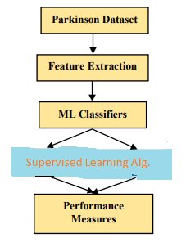

Fig. 1. Block Diagram of the Parkinson Disease Prediction

According to the dataset's statistics shown in Fig.2, there were 74% subjects with Parkinson's disease and 26% healthy individuals. The UCI repository's dataset was retrieved.

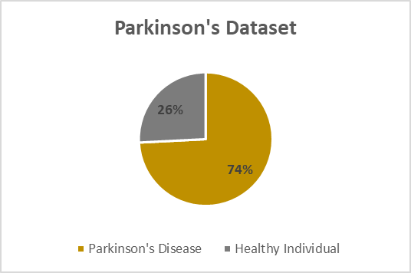

Fig 2. Parkinson’s Dataset from UCI ML Repository

*A.* Feature Extraction

|  |  |  |
| --- | --- | --- |
| **CLASSIFIERS** | **SVM** | **KNN** |
| **ACCURACY(A)** | 89.74% | 93.84% |
| **SENSITIVITY(S)/RECALL** | 80.43% | 86.0% |
| **SPECIFICITY(S)** | 92.61% | 96.5% |
| **PRECISION(P)** | 77.08% | 89.58% |
| **F-MEASURE(FM)** | 78.71% | 87.75% |

During the disease classification stage, it is necessary to extract important and critical features through the training and testing dataset. The features extracted are the measure of vocal frequency (Max, Min and Avg), the variations in frequency and amplitude, noise measurement, the nonlinear dynamic complexity and signal fractal scaling is shown in Table. 1.

TABLE 1.FEATURES EXTRACTED FROM THE PARKINSOS’S DATASET

|  |  |  |
| --- | --- | --- |
| **S.**  **No** | **Features** | **Parameters** |
| 1 | MDVP:  Fhi Hz) | Maximum Vocal Frequency |
| Fo (Hz) | Average Vocal Frequency |
| Flo (Hz) | Minimum Vocal Frequency |
| 2 | Jitter (%) | Several ways to measure frequency variations |
| Jitter (Abs) |
| RAP |
| PPQ |
| 3 | Shimmer | A variety of methods for measuring amplitude differences |
| Shimmer (dB) |
| Shimmer: APQ3 |
| Shimmer:  APQ5 |
| APQ |
| Shimmer:  DDA |
| 4 | NHR | It describes the proportion of noise to vocal tonal elements |
| HNR |
| 5 | Recurrence  Period  Density  Entropy | It measures the nonlinear dynamic complexity |
| D2 |
| 6 | Detrended  Fluctuation  Analysis | Exponent of signal fractal scaling |
| 7 | Spread1 | It calculates the nonlinear fundamental frequency variation. |
| Spread2 |
| PPE |
| 8 | Status | Parkinson’s  Disease, Healthy Individual |

Based on this study the 21 features are extracted from the dataset, in which the five statistical features named mean, standard deviation, variance, skewness and kurtosis are computed for the vocal frequency with the ranges of maximum, average and minimum and it is shown in the Table.2.

TABLE 2.FEATURES EXTRACTED FROM THE PARKINSOS’S DATASET

In the proposed study, the features are extracted and the categorization is done using the two ensemble approaches. The methods known as Support vector machine (SVM) and KNN are still being discussed along with the performance analysis.

*B. Support vector machine* (SVM)

In order to forecast unknown target features, an efficient machine learning method called ensemble learning incorporates multiple learners as opposed to using a single learner. Building a powerful classifier from a group of learners in order to obtain more accurate classification results is the main objective of ensemble learning. In this study, the effects of applying the wellknown ensemble learning approaches of Support vector machine and KNN to the experimental data are compared.

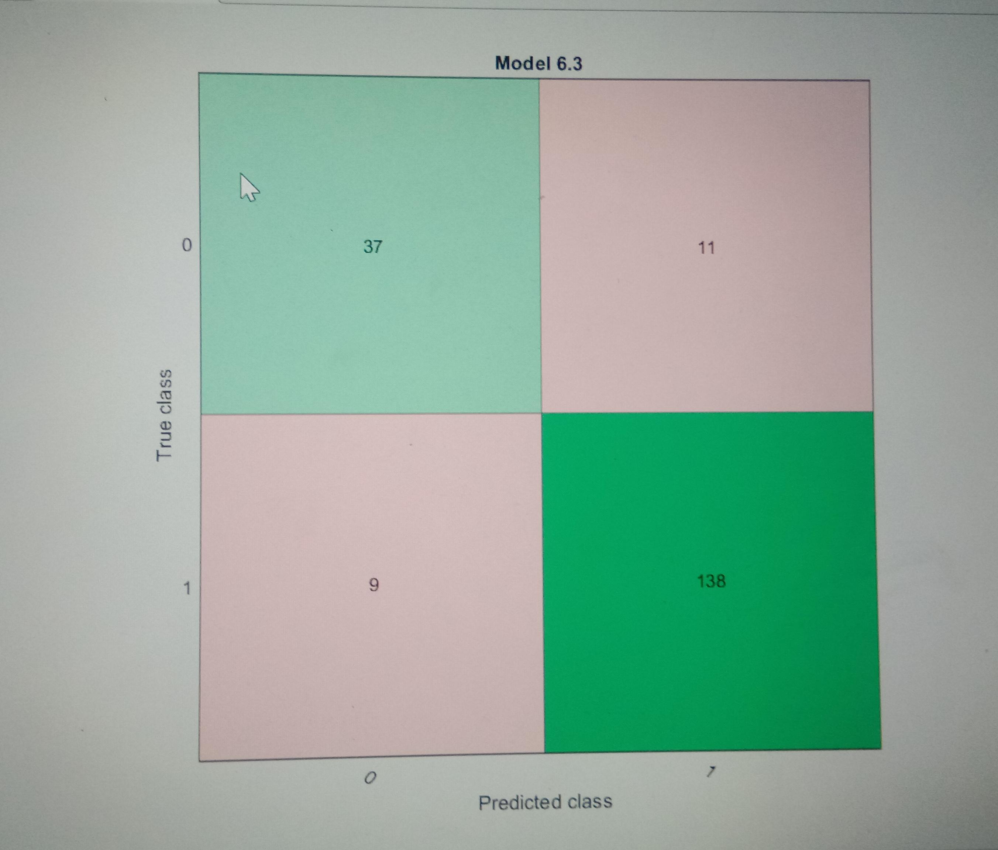

Fig. 3. Parkinson's Dataset SVM Confusion Matrix

Figure 3 displays the SVM confusion matrix.

Support Vector Machine or SVM is one of the most popular Supervised Learning algorithms, which is used for Classification as well as Regression problems. However, primarily, it is used for Classification problems in Machine Learning.

*C.* k-nearest neighbors*(K-NN)*

The k-nearest neighbors algorithm, also known as KNN or k-NN, is a non-parametric, supervised learning classifier, which uses proximity to make classifications or predictions about the grouping of an individual data point. It was first developed by Evelyn Fix and Joseph Hodges in 1951, and later expanded by Thomas Cover. It is used for classification and regression.

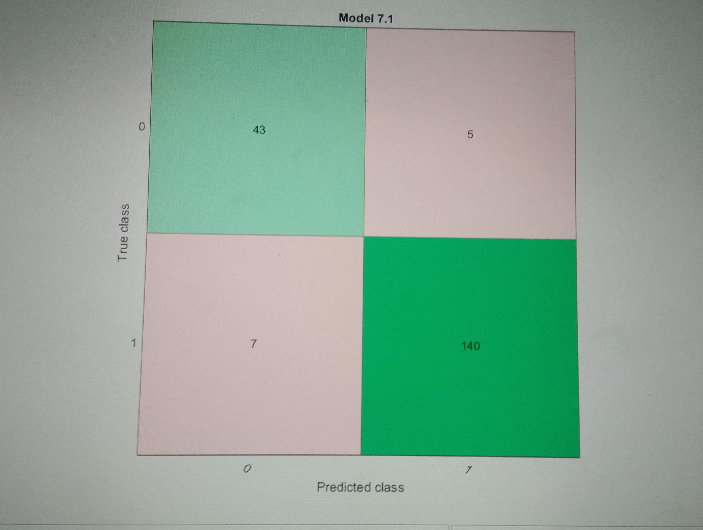

Fig. 4. Parkinson's Dataset K-NN Confusion Matrix

It is also called a **lazy learner algorithm** because it does not learn from the training set immediately instead it stores the dataset and at the time of classification, it performs an action on the dataset.

Comparing support vector machine (SVM) algorithms and K-Nearest Neighbors classifiers, the former had much more predictive capability. Figure 4 displays the K-NN confusion matrix.

IV. PEFORMANCE MEASURES

i) Confusion Matrix

A classification model's performance when applied to a set of test data for which the real values are known is often summarized in this table. It is a two-dimensional table with two dimensions: True Value and Predicted Value is shown in fig.5. An error matrix is another name for a confusion matrix.

|  |  |  |  |
| --- | --- | --- | --- |
| **True**    **Class** | **0** | **TP** | **FP** |
| **1** | **FN** | **TN** |
| **Error Matrix** | | **0** | **1** |
| **Predicted Class** | |

# Fig.5. Confusion Matrix

1. **True Positive (TP):** Healthy individuals are accurately categorised as Parkinson's disease free patients.
2. **False Positive (FP):** Healthy individuals are mistakenly categorised as Parkinson's disease.
3. **True Positive (TP):** Healthy individuals are accurately categorised as Parkinson's disease free patients.
4. **False Positive (FP):** Healthy individuals are mistakenly categorized as Parkinson's disease.

The confusion matrix serves as the basis for calculating the classifiers' performance metrics, and the formula is provided below:

Table 3 calculates and displays the performance metrics for the SVM and K-NN classifiers in percentage form.

TABLE 3.PEFORMANCE MEASURES OF THE PARKINSON’S DATASET AMONG

CLASSIFIERS

|  |  |  |
| --- | --- | --- |
| **Ensembled**  **Classifiers Vs**  **Performance**  **Metrics** | **SVM** | **K-NN** |
| **Accuracy** | 89.74% | 93.84% |
| **SENSITIVITY(S)/**  **RECALL** | 80.43% | 86.0% |
| **SPECIFICITY(S)** | 92.61% | 96.5% |
| **PRECISION(P)** | 77.08% | 89.58% |
| **F-MEASURE(FM)** | 78.71% | 87.75% |

V. RESULT AND DISCUSSION

Parkinson's disease can be identified using ensemble classifiers and algorithms. This algorithm determines if the patient has Parkinson's disease or not based on the important elements from the investigation's data. The data sets are analyzed using two classifiers, with the K-NN classifier having the highest accuracy of 93.84%. As a result, those who are most likely to have Parkinson's disease can be found using supervised machine learning algorithms. Accuracy, Sensitivity and Specificity, precision and F-Measure and other performance metrics are used to evaluate the

Classification technique. They are seen in Figure 6

* Accuracy (A) = TP+TN/TP+TN+FP+FN
* Sensitivity (S)/Recall = TP/TP+FN
* Specificity (s) = TN/TN+FP
* Precision (P) = TP/TP+FP
* F-Measure (FM) = 2 * ((P * Recall) / (P + Recall))

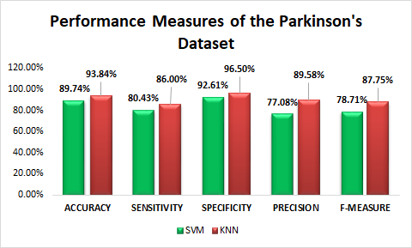

Fig.6. Performance Metrics of the ensembled classifier algorithms for the prediction of Parkinson’s disease

**CONCLUSION**

* Parkinson's disease detection is possible with ensembled classifiers and algorithms. This algorithm determines if the patient has Parkinson's disease or not by using the salient features from the investigation's data. The data sets are analyzed using two classifiers, with the KNN classifier having the best accuracy (93.84%). As a result, those who are most likely to have Parkinson's disease can be found using supervised machine learning algorithms. Accuracy,sensitivity, specificity, precision, and f-measure are the performance criteria used to evaluate the classification strategy, and they are depicted in fig. The KNN classifier outperforms the SVM classifier in terms of data analysis and output quality

# 

# **References**

1. Gunduz, H. Deep Learning-Based Parkinson’s Disease Classification Using Vocal Feature Sets. *IEEE Access* **2019**, *7*, 115540–115551.
2. Braak, H.; Del Tredici, K.; Rüb, U.; De Vos, R.A.; Steur, E.N.J.; Braak, E. Staging of brain pathology related to sporadic Parkinson’s disease. *Neurobiol. Aging* **2003**, *24*, 197–211.
3. Alzubaidi, M.S.; Shah, U.; DhiaZubaydi, H.; Dolaat, K.; Abd-Alrazaq, A.A.; Ahmed, A.; Househ, M. The Role of Neural Network for the Detection of Parkinson’s disease: A Scoping Review. *Healthcare* **2021**, *9*, 740
4. Maitín, A.M.; García-Tejedor, A.J.; Muñoz, J.P.R. Machine Learning Approaches for Detecting Parkinson’s Disease from EEG Analysis: A Systematic Review. *Appl. Sci.* **2020**, *10*, 8662
5. Van Den Eeden, S.K.; Tanner, C.M.; Bernstein, A.L.; Fross, R.D.; Leimpeter, A.; Bloch, D.A.; Nelson, L.M. Incidence of Parkinson’s disease: Variation by age, gender, and race/ethnicity. *Am J Epidemiol.* **2003**, *157*, 1015–1022